**I.** Set Theory

A set is _____________________________________________________________________

* Objects in a set are called ________________ or ________________
* Sets can be described in three ways:

1.

2.

3.

* Use ______________ ______________ to name and identify a set.

For example: set **A** = {2, 4, 6, 8}

* A set that contains NO elements (has no members) is called an __________________

or a __________________

The correct notation used for this is**:** ________________

The wrong notation is**:** _________

**II.** Number Sets: how our number system is organized

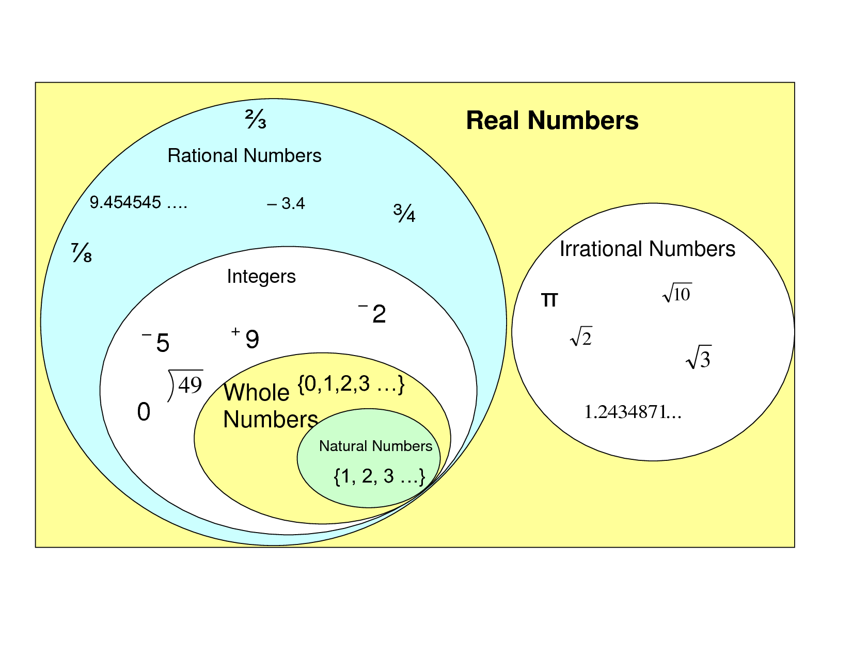

* **Natural numbers** (counting numbers): Begin counting with the number 1
* **Whole numbers**: Begin with zero and continue with the counting numbers
* **Integers**: Positive and Negative whole numbers
* **Rational numbers**: Numbers that can be written as a fraction, including terminating

decimals and repeating decimals

* **Irrational numbers**: Numbers that cannot be written as a fraction which include infinite,

non-repeating decimals

* **Real numbers**: All the numbers on a number line

All numbers that can be written as a decimal

**EXAMPLE:** List or complete the list of numbers in each set that is being described.

1. the set of integers between -5 and 3: ___________________________________________

2. {5, 6, 7, …, 11} : ___________________________________________________________

3. {x | x is a counting number between six and seven} : ______________________________

**III.** Finite and Infinite sets

Finite Set has ________________________________________________________________

Infinite Set has _______________________________________________________________

**EXAMPLE:** List or complete the list of numbers in each set that is being described and tell which type of set it is.

1. the set of all counting numbers greater than 20 ___________________________________

2. {x | x is a positive multiple of 5} ________________________________________________

3. the set of America’s Great Lakes ______________________________________________

_________________________________________________________________________

**IV.** An element of a set.

To show if an item is an element of a set (member of a set), use this symbol**:** ______

To show if an item is not an element of a set (not a member of a set), use this symbol**:** ______

**EXAMPLE:** True or False, is the item an element of the given set?

1. 3 ∈ {1, 2, 3, 4, 5} _____________

2. 0 ∈ {9, 10, 11, 12} _____________

3. ∉ _____________

4. b ∈ {h, c, d, a, b} _____________

**V.** Equality of sets.

Two sets are equal, if and only if (iff), ____________________________________________

___________________________________________________________________________

___________________________________________________________________________

**EXAMPLE:** Are the two sets equal?

1. A = {-4, 3, 2, 5} B = {-4, 0, 3, 2, 5} A = B? __________

2. A = {3} B = { x | x is a counting number between 1 and 5} A = B? __________

3. A = {k, c, a, r} B = {c, r, k, a} A = B? __________

________________________________________________________________